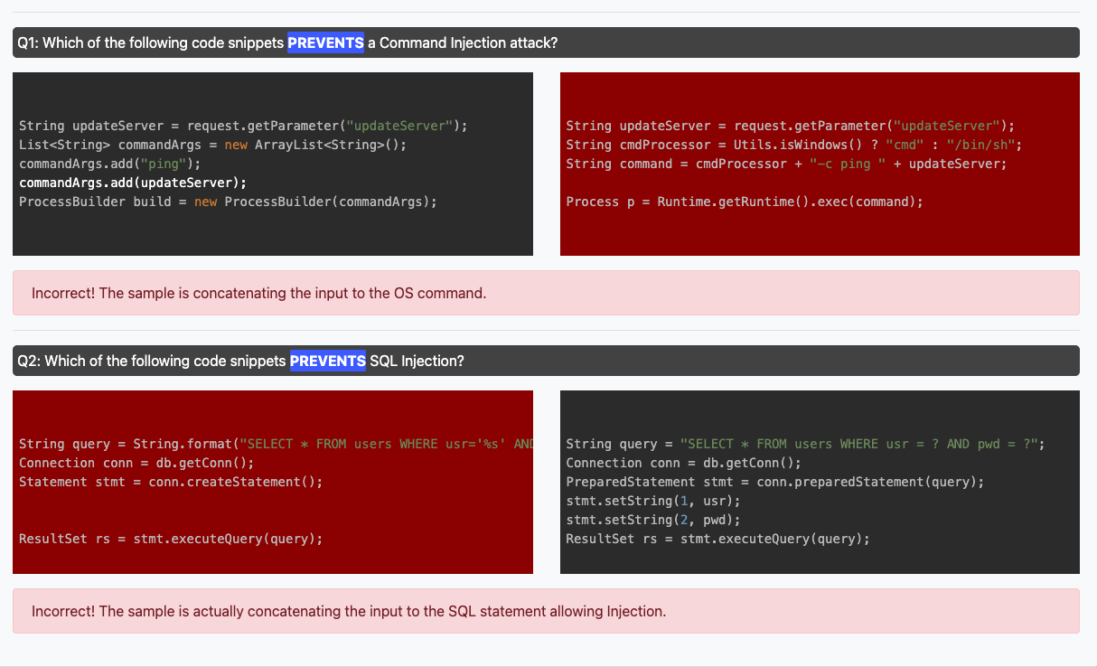

Q1: Option 1 is correct because it does not use user inputs to create a command but instead used builds commands using “commandArgs.add()” and “ProccessBuilder()”
Q2: Option 2 is correct because it does not use the actual user input, ‘%s' but instead has “usr = ?”.

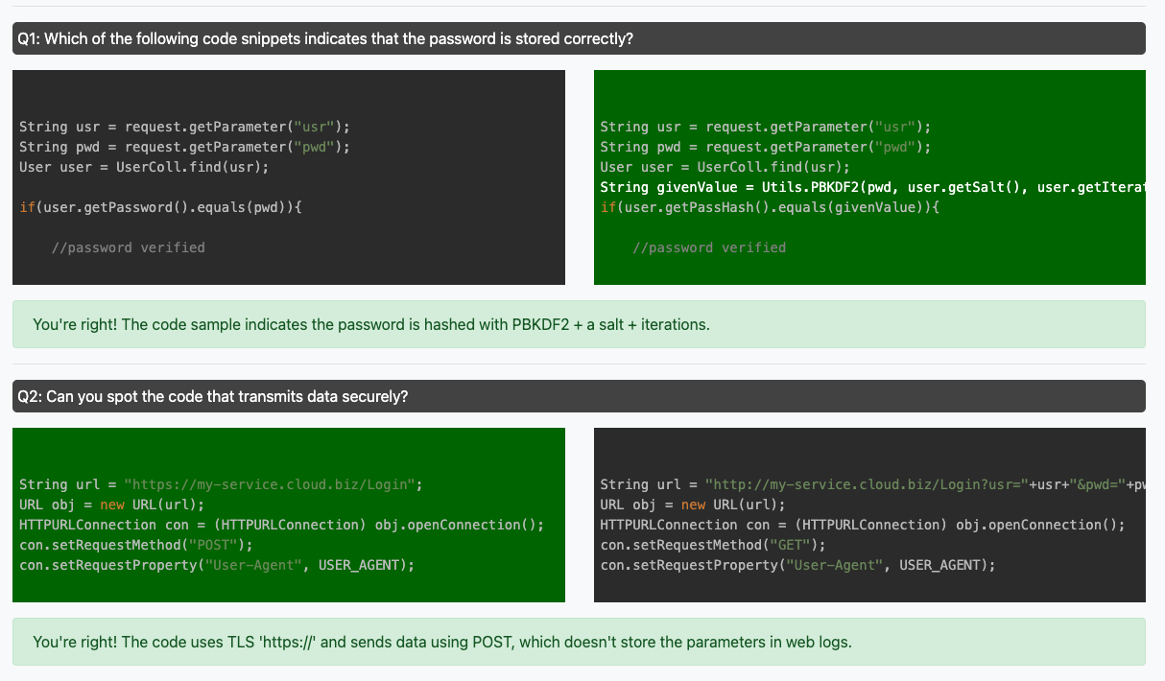
Q1: Option 2 is correct because it’s password is encrypted with AES. We know this because the code has to decrypt the password to use it to compare it to the entered password.
Q2: Option 1 is correct because it sends the password and user name via post instead of in the url where it is public.

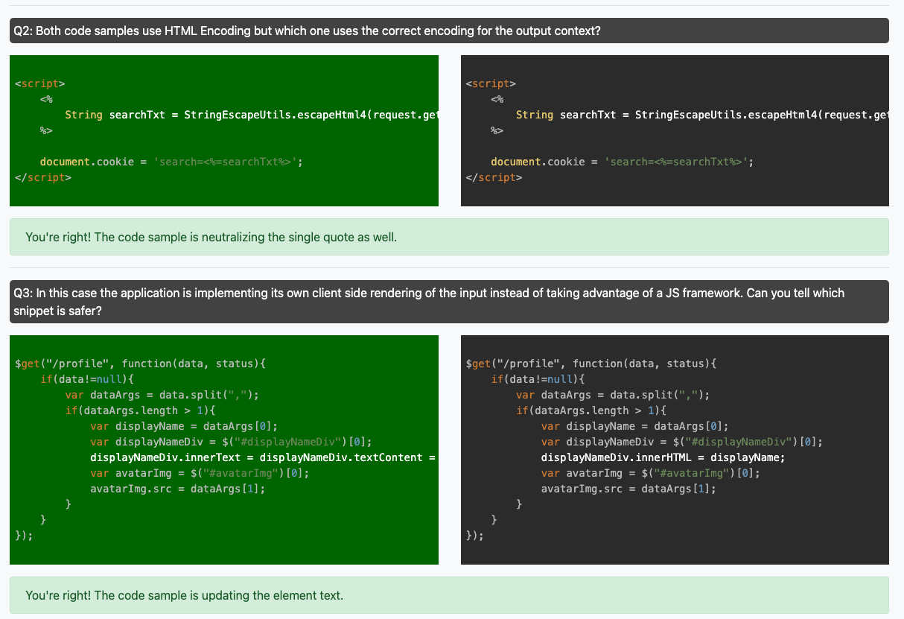
Q2: option 1 is correct because it replaces dangerous characters in the user input before displaying it.
Q3: Option 1 is correct because it ensures that the input is displayed as “textcontent” of the div instead of displaying it as a possibly dangerous line of code in the div.

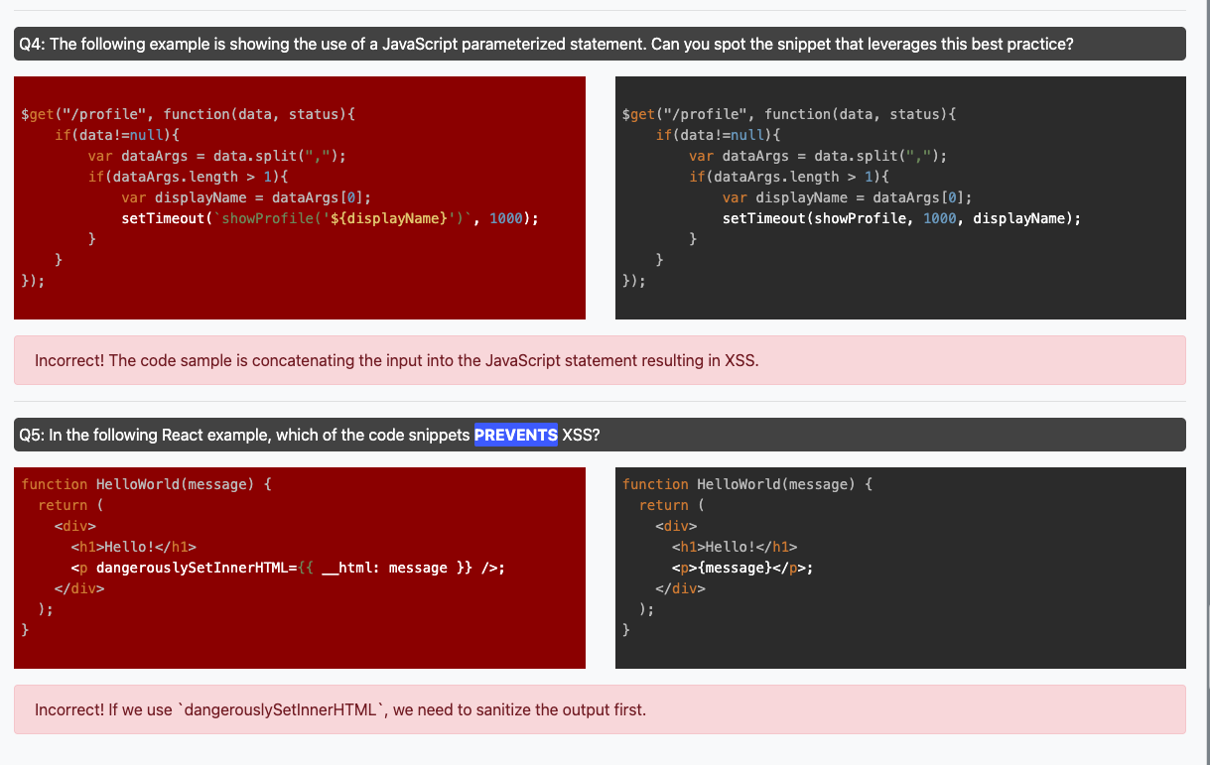Q4: Option 2 is correct because it does not using the input variable $displayname directly in the script.
Q5: Option 2 is incorrect because it displays the message safely as a string in <p> instead of as innerhtml without sanitizing it first. Setting something as innerhtml is dangerous because innerhtml is run as code, whereas a string in a <p> is not run as code.

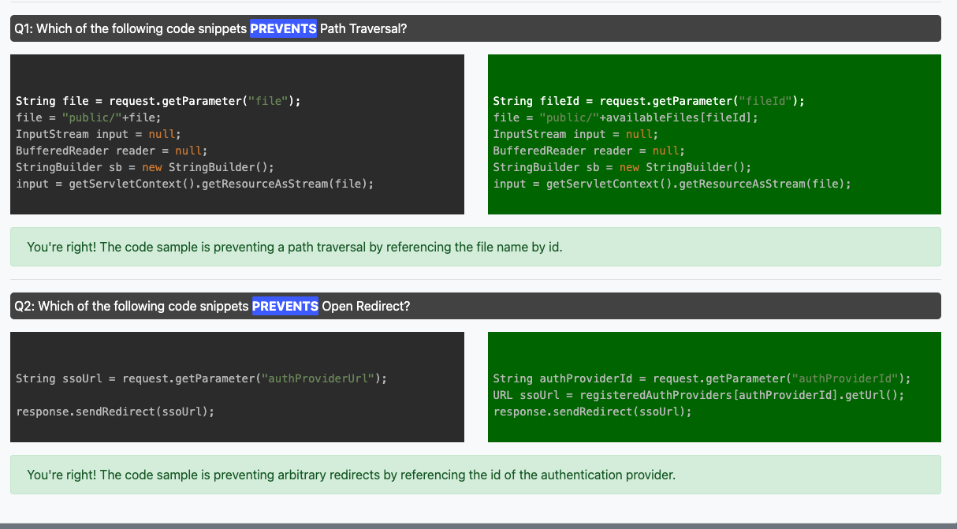
Q1: Option 2 is correct because it uses a file ID instead of the actual file.
Q2: Option 2 is correct because it starts by getting an ID instead of a url and then obtains the url by checking the ID with a list of registered providers.

